

Documento de Requisitos do Projeto (BRD)

Pesquisa de Satisfação - PesqBD

Início do Projeto:

Fevereiro de 2016

Versão do Documento:

1.0

Projeto realizado por alunos da turma BD16105NA da Faculdade Batista de Minas Gerais no primeiro semestre letivo de 2016 e guiado pelo professor Maurício Veloso Schvartzman.

# Versões do Documento

|  |  |  |
| --- | --- | --- |
| Data | Versão | Descrição |
| 23/08/2016 | 1.0 | Documentação da versão 1.0 em funcionamento |
|  |  |  |
|  |  |  |
|  |  |  |
|  |  |  |
|  |  |  |
|  |  |  |
|  |  |  |
|  |  |  |

# Aprovação do Documento

|  |  |  |  |
| --- | --- | --- | --- |
| **Papel** | **Responsável** | **Assinatura** | **Data** |
| Patrocinador | FBMG |  |  |
| Idealizador | Maurício Veloso |  |  |
| Gerente de Projeto | Maurício Veloso |  |  |
| Arquiteto de Sistema | BD16105NA |  |  |
| Desenvolvimento | BD16105NA |  |  |
| Qualidade | BD16105NA |  |  |

# Introdução

## Sumário do Projeto

### Objetivos

* Adquirir experiência prática em desenvolvimento de software em equipe.
* Prover um sistema online via navegador com layout responsivo.
* Criar uma plataforma de pesquisa de satisfação diferenciada.
* Facilidade, eficiência e dinamismo na usabilidade.

### Background

É clara a existência de dificuldade em receber boa quantidade de feedback em pesquisas de satisfação, seja por falta de alcance ao público alvo, falta de interesse, dificuldade de acesso às plataformas para responder as perguntas, má exibição dos dados coletados ou mesmo por conta da falta de facilidade na análise.

Portanto, em busca de experiência prática por parte dos alunos em um projeto de software e melhorar processos de pesquisas de satisfação, surgiu a ideia de criar um sistema de perguntas e respostas através da internet, buscando facilidade de uso tanto utilizando um computador ou dispositivos móveis por parte dos pesquisadores e dos usuários que respondem as perguntas.

#### Fatores de Sucesso

* Não houver outras plataformas que já façam o que esse projeto almeja realizar.
* Boa integração da equipe.
* Boa instrução à equipe, organização e gerência de conflitos.
* Cumprimento das expectativas para o semestre até o final do mesmo.

## Project Scope

[Describe what work is in scope for the project, and specifically what work is out of scope… beyond the current budget, resources and timeline as approved by the project stakeholders. This is designed to prevent “scope creep” of additional features and functions not originally anticipated.]

### In Scope Functionality

* Create name records for widgets by category
  + Supply Chain
  + Production Lines
  + Internal web apps
  + External web apps
* Ability to create/delete widget names restricted by role
* Search by name, team, date, last modified
* Synchronize widgets across product/operations lines
* Provide audit trail
* Reporting on new, modified, and archived widgets by time period and team

### Out of Scope Functionality

* Create widgets for subsidiary company product lines
* Search by approver, or rationale
* Archiving of widget objects

## System Perspective

[Provide a complete description of the factors that could prevent successful implementation or accelerate the projects, particularly factors related to legal and regulatory compliance, existing technical or operational limitations in the environment, and budget/resource constraints.]

### Assumptions

* Inventory of existing widgets completed by Q1.
* Testing data comprises scrubbed production data as of December 31.

### Constraints

* Impending changes to privacy regulations may impact data dictionary design.
* Timeline for enterprise platform updates will impact execution of testing plan.

### Risks

* Previously approved Q2/Q3 development projects may limit availability of development and QA resources, necessitating outsourcing or additional budget requisitions to meet the anticipated timeline.
* .

### Issues

# Business Process Overview

[Describe how the current process(es) work, including the interactions between systems and various business units. Include visual process flow diagrams to further illustrate the processes the new product will replace or enhance.

Use case documentation and accompanying activity or process flow diagrams can be used to create the description(s) of the proposed or “To-Be” processes.]

## Current Business Process (As-Is)

At any point during or after deployment of web apps or web sites (internal or external) to support business activities, development/support teams may create and deploy widgets.

1. CMS / database administrators for the employee portal use the CMS tool to create widgets. They can test widgets in the designated staging environment, then register them and deploy to production.
2. Development teams may deploy widgets to development and testing environments set up for their development projects. They must check widget code into and out of the source code repository according to their projects’ development schedule.

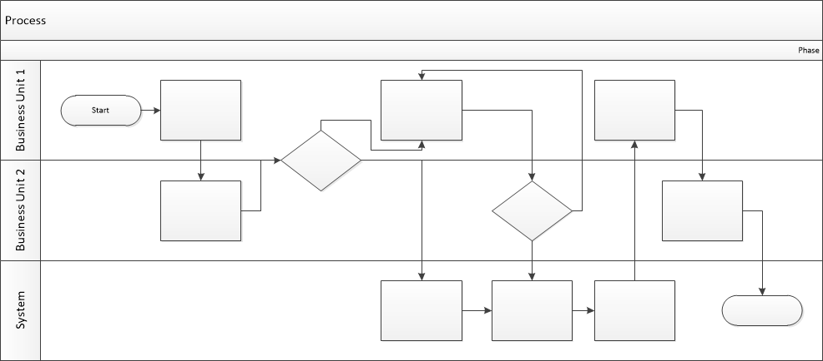

## Proposed Business Process (To-Be)

1. Technical Lead searches repository
2. If widget is not found, user creates a new widget name record.
3. WINS validates that all fields have been completed.
4. WINS confirms that no similar widgets exist
5. User confirms record to be created.



1. User searches repository to locate existing widget description.
2. WINS displays record
3. User selects Edit to open and modify record
4. WINS validates all fields completed correctly
5. User confirms changes.
6. WINS confirms changes and updates Audit table.



# Business Requirements

[The specific business requirements elicited from stakeholders should be listed, categorized by both priority and area of functionality to smooth the process of reading and tracking them. Include links to use case documentation, and other key reference material as needed to make the requirements as complete and understandable as possible. You may wish to incorporate the functional and non-functional requirements into a traceability matrix that can be followed throughout the project.]

The requirements in this document are prioritized as follows:

|  |  |  |
| --- | --- | --- |
| **Value** | **Rating** | **Description** |
| 1 | Critical | This requirement is critical to the success of the project. The project will not be possible without this requirement. |
| 2 | High | This requirement is high priority, but the project can be implemented at a bare minimum without this requirement. |
| 3 | Medium | This requirement is somewhat important, as it provides some value but the project can proceed without it. |
| 4 | Low | This is a low priority requirement, or a “nice to have” feature, if time and cost allow it. |
| 5 | Future | This requirement is out of scope for this project, and has been included here for a possible future release. |

## Functional Requirements

| **Req#** | **Priority** | **Description** | **Rationale** | **Use Case Reference** | **Impacted Stakeholders** |
| --- | --- | --- | --- | --- | --- |
| **General / Base Functionality** | | | | | |
| FR-G-001 | 1 | A new Master Widget repository shall be created to house the name records and links to the widget objects. | Single repository simplifies management of widget development across 30+ global development teams |  | Development teams  Infrastructure engineers |
| FR-G-002 | 1 | A widget shall be defined in the repository via a unique identifier and name combination. | ID+Name eliminates duplicate widget name records |  |  |
| FR-G-003 |  |  |  |  |  |
| FR-G-004 |  |  |  |  |  |
| FR-G-005 |  |  |  |  |  |
| **Security Requirements** | | | | | |
| FR-S-001 | 1 | Widget creation in the repository shall be limited to users with Team Lead or System Administrator, |  |  |  |
| **Reporting Requirements** | | | | | |
| FR-R-001 | 2 | The system shall generate a weekly Report of Widget Name Status Changes |  |  |  |
| **Usability Requirements** | | | | | |
| FR-U-001 | 1 | User interface for the WINS repository shall be responsive, allowing for proper display on tablet, laptop, and desktop devices. |  |  |  |
| **Audit Requirements** | | | | | |
| FR-A-001 | 1 | Any change to a widget name record shall be appended with user ID and date/time stamp. |  |  |  |

## Non-Functional Requirements

[Include technical and operational requirements that are not specific to a function. This typically includes requirements such as processing time, concurrent users, availability, etc.]

|  |  |
| --- | --- |
| **ID** | **Requirement** |
| NFR-001 | The WINS repository shall accommodate up to 100 users concurrently. |
| NFR-002 | The WINS repository shall be designated at Level 2 for availability and SLA purposes. |
| NFR-003 |  |
| NFR-004 |  |
| NFR-005 |  |

# Appendices

## List of Acronyms

[If needed, create a list of acronyms used throughout the BRD document to aid in comprehension.]

## Glossary of Terms

[If needed, identify and define any terms that may be unfamiliar to readers, including terms that are unique to the organization, the technology to be employed, or the standards in use.]

## Related Documents

[Provide a list of documents or web pages, including links, which are referenced in the BRD.]